|  |
| --- |
|  |
| National Institute of Technology Project Report |
| On  “Marine Drone”  Under the domain  **Marine Waste Management**  **SUBMITTED BY:**  TEAM NAUTICA  ANUPAM KARN  SANSKAR VAIDYA  NIKHIL VERMA |
|  |



**ROBO-FISH**

**ABSTRACT**

In this paper, we have presented the design for a simple robotic fish inspired by the maneuvering mechanisms of real fishes. The body of the fish is divided into three parts so that all the parts can be controlled separately and the motion of a solid object can simulate the motion of a real fish. The tail and all the body parts use servo motors for the movement. The servo motor is being controlled by an Arduino board. And IR sensors have also been used in order to detect an interference in the path.

**INTRODUCTION**

Robotic fish is a bio-mimetic robot obtaining its design inspiration from aquatic animals. Ex: Shark, Fish, Eel, Tuna etc. For long, researchers have been interested in the highly efficient propulsion of fish and now have attempted to apply it to underwater robots for fish-like swimming with increased horizons of underwater applications, there is much pressing on efficient equipments for these operations Efficiency and propulsive performance for underwater applications essentially requires fish-like performance compared to conventional technique. Evolution has made fishes excellent swimmers. And the design of their structure is naturally refined for efficiency.

**BASIS**

Underwater exploration has been an important preoccupation of researchers since a long time. In terms of scientific results, immense data of critical importance is produced by most exploration missions of such kind (Dover, 2000). From the discovery of new life forms in areas we earlier thought were inhabitable to assessing the impact of climate change on coral reefs or environmental monitoring, underwater exploration has loads of benefits. Today underwater exploration is mainly dominated by manned or unmanned submarine-type vehicles. Submarines have been considered to be the most successful in this respect till now but clearly, they lack several important features of natural swimmers like flexibility, ease of maneuverability and energy efficiency which lead to fish swimming being better adapted ecologically in comparison to submarines. A new paradigm in unmanned underwater exploration has been unleashed with the introduction of robotic fishes. The efficient exploration of the unpredictable terrain and cluttered environment of the ocean seabed asks for miniature sized agents with fast response rates. A robotic fish would serve as a perfect agent for such exploration missions.

As an exercise in mechanical prototyping , team of three designed and constructed robotic fish out of a 3-D printed plastic material Team Fish decided to create a biomimetic fish that could actuate its body and tail to move forward inside water. It could detect the presence of any obstacles and change its way accordingly. The final prototype is fully functional and exhibits an ice biomimetic motion. This report details the design of the robot.

**MECHANISM**

Fish robots generally do not mimic the same fish motion in nature and, hence, have different swimming mechanisms. The main element which distinguishes fish robots from other types of underwater vehicles is their propulsion system. Fishes propel through undulation or oscillation of different parts of their body or fins called propulsions. When a fish passes a propulsive wave by its body or its fins in the opposite direction of its movement at a faster speed than swimming speed, its swimming method is referred to as undulation. On the other hand, in oscillation mode, fish generates propulsive waves by oscillating a certain part of its body around its base (Sfakiotakis, Lane, & Davies, 1999). presents some basic terminologies used in this chapter. Taking

fish propulsions into account, fish swimming modes are categorized into two main groups. Some fishes swim using their Body and/or Caudal Fins (BCF), whereas others apply their Median and/or Paired Fin (MPF).

**Mechanism of Swimming of Fishes**

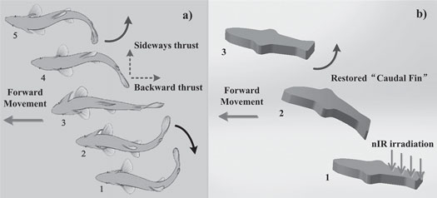

**Mechanism of Turning Fishes Turn**

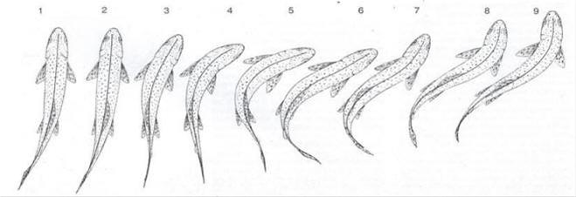

**Mechanism of Robotic Fish swimming**

There are four categories of mechanical design for swimming robotic fishes

1. ***Changing wave***: Body wave from head to tail is used forpropelling. A smooth motion of entire body is required with many hinges and joints. Complex control system. Can realize delicate motion, and work well in narrow water area like a coral reef.
2. ***Body Foil*:** Fish pushes the water away behind them byboth oscillation of its tail fin and wave motion of the body. Trout and Salmon are fish typical of those using this swimming method.
3. ***Oscillating Wing*:** Fish using this method derive nearly allof its propulsive force from an oscillating wing-shaped tail fin. These fish has a crescent and wing-shaped tail fin. Tuna and Bonito use this method.
4. ***Oscillating Plate*:** Fish using this method oscillate only atail fin like a plate without moving the body

**Turning Modes**

* The fish robot swings its tail only to one side during a turning. It is considered that this mode is the most fundamental and important turning mode, because the robot can turn with various turning diameter and speed in this mode
* The fish robot swims straight, and gets kinetic energy. Next, the fish robot turns its tail to one side, and keeps the posture to the side. Then the fish robot turns by hydrodynamics force. It is considered that this mode gets smaller turning diameter
* The fish robot swings its tail to one side rapidly from stationary state. In this turning mode, inertia force and friction force of the moving tail and the body are changed to the moment of rotation

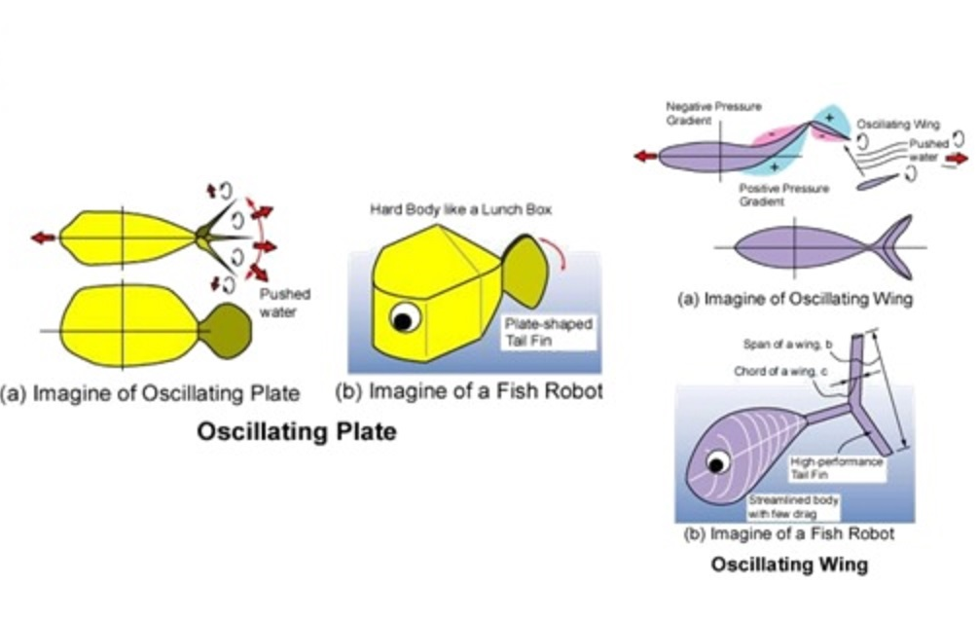

**WORKING OF TOOLS**

* ***SERVO MOTOR*:** Servo motors have been around for a long time and are utilized in many applications. They are small in size but pack a big punch and are very energy-efficient. These features allow them to be used to operate remote-controlled or radio-controlled toy cars, robots and airplanes. Servo motors are also used in industrial applications, robotics, in-line manufacturing, pharmaceutics and food services. But how do the little guys work?   
    
  The servo circuitry is built right inside the motor unit and has a positional shaft, which usually is fitted with a gear. The motor is controlled with an electric signal which determines the amount of movement of the shaft.

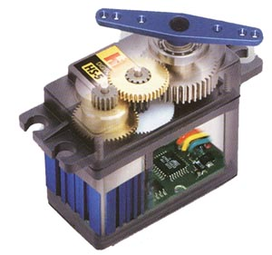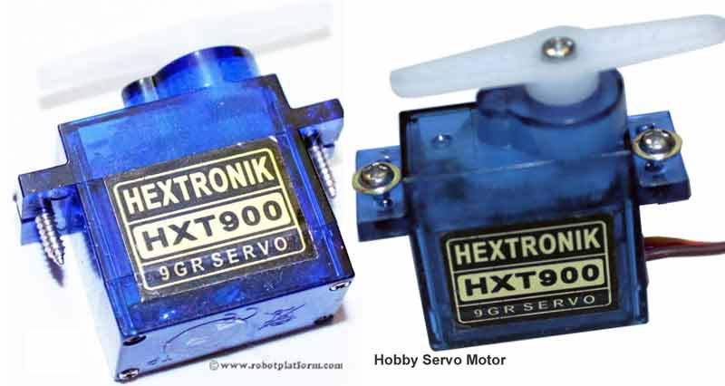

When the shaft of the motor is at the desired position, power supplied to the motor is stopped. If not, the motor is turned in the appropriate direction. The desired position is sent via electrical pulses through the signal wire. The motor's speed is proportional to the difference between its actual position and desired position. So if the motor is near the desired position, it will turn slowly, otherwise it will turn fast. This is called proportional control. This means the motor will only run as hard as necessary to accomplish the task at hand, a very efficient little guy.

* ***ARDUINO*** : Arduino is an open-source prototyping platform based on easy-to-use hardware and software. Arduino boards are able to read inputs - light on a sensor, a finger on a button, or a Twitter message - and turn it into an output - activating a motor, turning on an LED, publishing something online. You can tell your board what to do by sending a set of instructions to the microcontroller on the board. To do so you use the Arduino programming language (based on Wiring), and the Arduino Software (IDE), based on Processing.

Arduino was born at the Ivrea Interaction Design Institute as an easy tool for fast prototyping, aimed at students without a background in electronics and programming. As soon as it reached a wider community, the Arduino board started changing to adapt to new needs and challenges, differentiating its offer from simple 8-bit boards to products for IoT applications, wearable, 3D printing, and embedded environments. All Arduino boards are completely open-source, empowering users to build them independently and eventually adapt them to their particular needs. The software, too, is open-source, and it is growing through the contributions of users worldwide.

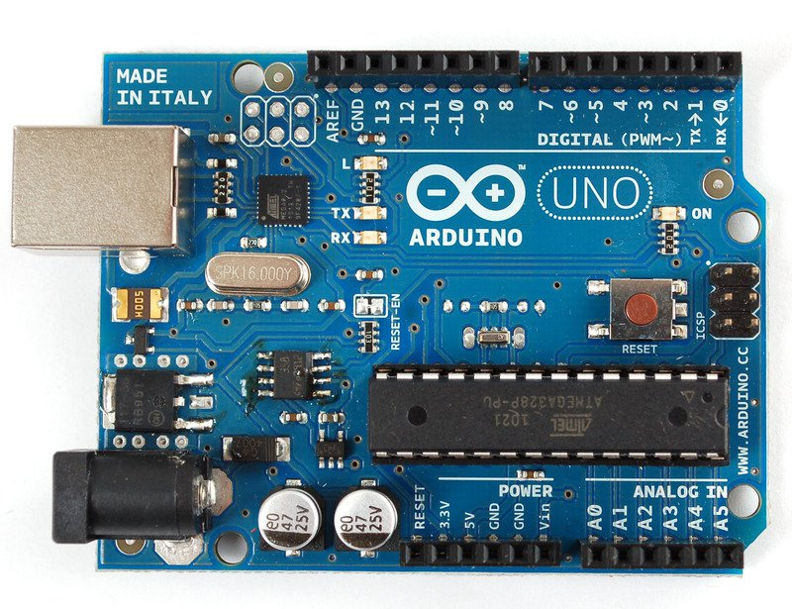

* ***IR SENSORS***: An infrared sensor is an electronic device, that emits in order to sense some aspects of the surroundings. An IR sensor can measure the heat of an object as well as detects the motion. These types of sensors measure only infrared radiation, rather than emitting it that is called as a passive IR sensor. Usually in the infrared spectrum, all the objects radiate some form of thermal radiations. These types of radiations are invisible to our eyes, that can be detected by an infrared sensor.The emitter is simply an IR LED (Light Emitting Diode) and the detector is simply an IR photodiode which is sensitive to IR light of the same wavelength as that emitted by the IR LED. When IR light falls on the photodiode. The resistances and these output voltages, change in proportion to the magnitude of the IR light received.

An infrared  sensor circuit is one of the basic and popular sensor module in an electronic device. This sensor is analogous to human’s visionary senses, which can be used to detect obstacles and it is one of the common applications in real time.

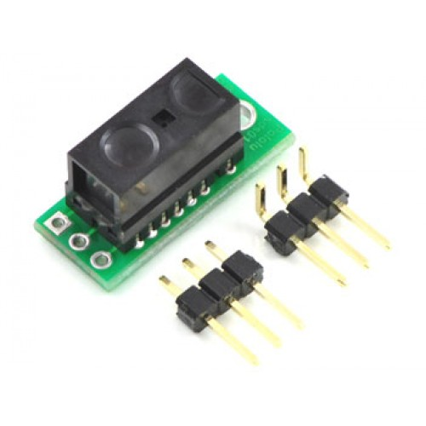

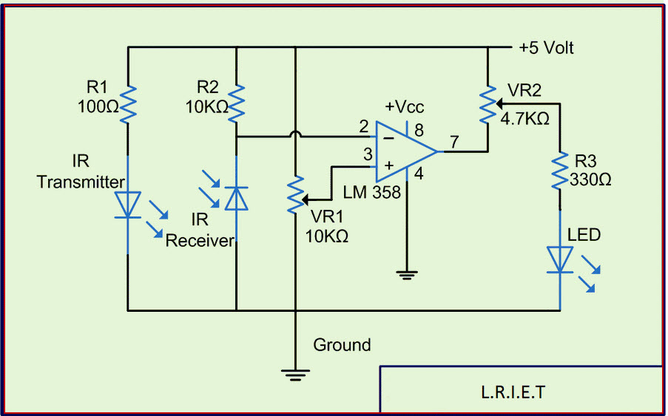

**WORKING AS A WHOLE**

We have designed the fish using the Google Sketchup Make software which is simple and easy to use. The fish is divided into three parts excluding the caudal fin , which is separate, in order to make the simulation as realistic as possible.

The fish will be printed using a 3d printer and will be made up of normal plastic.

We have used three servo motors in order to move all the three joints. Servo motors have been used because their frequency and velocity of rotation can be easily controlled by our Arduino.

The Arduino board has been programmed using an Arduino IDE in windows. The Arduino will be powered using batteries.

In order to detect objects and interferences in the path of the fish, we have fitted IR sensors in the front so, whenever and object comes in the way, the IR sensors will detect the thermal radiation coming from it and will automatically change the direction of the movement.

**BIBLIOGRAPHY**

* [www.open-electronics.org](http://www.open-electronics.org)
* Google Images
* en.wikipedia.org